

**A report on**

**“Anticipating Menstrual Migraine Using**

**Deep Learning”**

**Submitted in partial fulfilment for the award of the degree of**

**BACHELOR OF TECHNOLOGY (HONOURS)**

**IN**

**COMPUTER SCIENCE (DATA SCIENCE)**

**Submitted by**

**PRANAV POLAVARAPU**

**19BTRCR008**

**SUSHIL BOKADE**

**19BTRCR017**

**SAI KEERTHI CHELLURI**

**19BTRCR036**

**SAI SHARANYA Y**

**19BTRCR043**

**Under the guidance of**

**DR. MOHAMMED ZABEULLA A. N**

**School of Computer Science & Engineering**

**Jain (Deemed-To-Be) University**

**Department of Computer Science (Data Science)**

Jain Global Campus, Kanakapura Taluk - 562112

Ramanagara District, Karnataka, India

2021-2022



**DEPARTMENT OF COMPUTER SCIENCE & ENGINEERING**

Jain global campus, Kanakapura taluk Ramanagara District – 562112 Karnataka, India.

**CERTIFICATE**

This is to certify that the project work titled **“ANTICIPATING MENSTRUAL MIGRAINE USING DEEP LEARNING”** is carried out by **Pranav Polavarapu (19BTRCR008), Sushil Bokade (19BTRCR017), Sai Keerthi Chelluri (19BTRCR036), Sai Sharanya Y (19BTRCR043),** a bonafide students of Bachelor of Technology at the School of Computer Science & Engineering, Jain (Deemed-to-be) University, Bangalore in partial fulfilment for the award of degree Bachelor of Technology (Honours) in Computer Science (Data Science), during the Academic year **2022- 2023**.

|  |  |  |
| --- | --- | --- |
| **Prof. Mohammed Zabeeulla A N** | **Dr. S.Ramesh** | **Dr. Geetha G.** |
| Assistant Professor, | Program Head, | Director, |
| Dept. of CSE (DS) | Dept. of CSE (DS) | Dept. of CSE (DS) |
| School of Computer Science & Engineering | School of Computer Science & Engineering | School of Computer Science & Engineering |
| Jain (Deemed-to-be) University | Jain (Deemed-to-be) University | Jain (Deemed-to-be) University |
| Date: 10/04/2023 | Date: | Date: |

Name of the Examiner Signature:

1:

2:

**DECLARATION**

We, **Pranav Polavarapu (19BTRCR008), Sushil Bokade (19BTRCR017), Sai Keerthi Chelluri (19BTRCR036), Sai Sharanya Y (19BTRCR043),** are students of eighth semester **B. Tech. (Hons.) in Computer Science (Data Science)**, at School of Computer Science & Engineering, Jain (Deemed- To-Be) University, hereby declare that the project work titled **“ANTICIPATING MENSTRUAL MIGRAINE USING DEEP LEARNING”** has been carried out by us and submitted in partial fulfillment for the award of degree in **Bachelor of Technology (Honors) in Computer Science (Data Science)** during the academic year **2022-2023.**

Signature

**NAME 1: Pranav Polavarapu**

**USN:19BTRCR008**

**Name 2: Sushil Bokade**

**USN: 19BTRCR017**

**Name 3: Sai Keerthi Chelluri**

**USN: 19BTRCR036**

**Name 4: Sai Sharanya Y**

**USN: 19BTRCR043**

Place: Bangalore

Date: 10/04/2023

**ACKNOWLEDGEMENT**

*It is a great pleasure for us to acknowledge the assistance and support of a large number of individuals who have been responsible for the successful completion of this project work.*

*First, we take this opportunity to express our sincere gratitude to* ***School of Computer Science & Engineering, Jain (Deemed-to-be) University,*** *for providing us with a great opportunity to pursue our Bachelor’s Degree in this institution.*

*We place on record, our sincere thank you to* ***Dr. Geetha, Director,******School of Computer Science & Engineering****,* ***Jain (Deemed-to-be University),*** *for the continuous encouragement.*

*It is a matter of immense pleasure to express our sincere thanks to* ***Dr. S. Ramesh, Program******Head****,* ***Computer Science (Data Science)****,* ***Jain (Deemed-to-be) University,*** *for providing right academic guidance that made our task possible.*

*We would like to thank our Project Coordinator* ***Dr. M. John Basha, Assistant Professor, Dept. of Computer Science (Data Science), Jain (Deemed-to-be) University,*** *for providing right academic guidance that made our task possible.*

*We would like to thank our guide* ***Prof. Mohamed Zabeeulla, Assistant Professor****,* ***Dept. of Computer Science (Data Science)****,* ***Jain (Deemed-to-be) University,*** *for sparing his valuable time to extend help in every step of our project work, which paved the way for smooth progress and fruitful culmination of the project.*

*It is a matter of immense pleasure to express our sincere thanks to* ***Prof. Mohamed Zabeeulla, Assistant Professor, Dept. of Computer Science (Data Science), Jain (Deemed-to-be) University,*** *for providing right academic guidance that made our task possible.*

*We would like to thank all the staff members of* ***Dept. of Computer Science & Engineering, Jain (Deemed-to-be) University****, for their support.*

*We are also grateful to our family and friends who provided us with every requirement throughout the course.*

*We would like to thank one and all who directly or indirectly helped us in completing the Project work successfully.*

*Signature of Students*

# **TABLE OF CONTENTS**

|  |  |  |
| --- | --- | --- |
| **ABSTRACT** | | 7 |
| **LIST OF FIGURES** | | 8 |
| **Chapter 1** | |  |
| 1. **INTRODUCTION** | | 9 |
|  | * 1. Overview | 9 |
|  | * 1. Problem Definition | 9 |
|  | * 1. Objectives | 9 |
|  | * 1. Methodology | 9 |
|  | * 1. Hardware and Software Tools Used | 10 |
| **Chapter 2** | |  |
| 1. **LITERATURE SURVEY** | |  |
|  | * 1. Related Work | 11 |
|  | * 1. Existing System | 13 |
|  | * 1. Limitation of Existing System | 14 |
|  | * 1. Proposed System | 15 |
| **Chapter 3** | |  |
| 1. **METHODOLOGY** | | 16 |
|  | * 1. Dataset | 16 |
|  | * 1. Architecture | 16 |
|  | |  |
| **Chapter 4** | |  |
| 1. **TOOL DESCRIPTION** | | 17 |
|  | * 1. Hardware Requirements | 17 |
|  | * 1. Software Requirements | 17 |
| **Chapter 5** | |  |
| 1. **IMPLEMENTATION** | | 18 |
| **Chapter 6** | |  |
| 1. **RESULTS AND CONCLUSION** | | 22 |
|  | * 1. Result Discussion | 22 |
| **Chapter 7** | |  |
| 1. **FUTURE SCOPE** | | 23 |
| **REFERENCES** | | 24 |
| **APPENDIX** | | 25 |

# **ABSTRACT**

Menstrual Migraines are headaches that occur without any typical aura or sensory disturbances. They can be labelled as 'Migraine without Aura'. A woman could undergo menstrual migraine just before or during her period starts. This is majorly due to the drop in oestrogen levels in the body. Menstrual migraines can be intense, and they must be identified accurately and treated separately from regular ones. Anticipating Menstrual Migraines using Deep Learning methodology can help women in taking precautions beforehand and aid in improving their health. This paper provides an efficient approach by checking various feature correlations and implementing ANN model with tuned hyperparameters providing stronger accuracy.

# **LIST OF FIGURES**

|  |  |  |
| --- | --- | --- |
| **Fig. No.** | **Description of Figure** | **Page No.** |
| 1. | Female menstrual intensity cycle | 14 |
| 2. | percentage plot of frequency vs migraine type | 18 |
| 3. | histogram, boxplot and violin plot of intensity feature | 19 |
| 4. | Distribution plot with KDE and Boxplots for location feature | 19 |
| 5. | count plot for migraine types | 19 |
| 6. | model prediction output deployed on Gradio UI predicting types of migraines for various user inputs. | 21 |

# **Chapter 1**

**INTRODUCTION**

* 1. **Overview**

Menstrual migraines can be intense, and they must be identified accurately and treated separately from regular ones. Anticipating Menstrual Migraines using Deep Learning methodology can help women in taking precautions beforehand and aid in improving their health. This paper provides an efficient approach by checking various feature correlations and implementing ANN model with tuned hyperparameters providing stronger accuracy.

* 1. **Problem Definition**

The misdiagnosis of menstrual migraine during a woman's menstrual cycle has resulted in the improper medications being administered to women, which has a negative impact on their health. It is assumed that a migraine during a woman's period is a menstrual migraine, but this assumption is untrue.

**1.3 Objectives**

The goal of this project is to develop an automated deep learning model that recognizes, categorizes, and anticipates the occurrence of menstrual migraine in females. The severity of a woman's symptoms, such as throbbing, menstruation, nausea, vision abnormalities, intensity, and many more, will determine how severe the treatment will be*.*

* 1. **Methodology**

This model proposes an efficient methodology to accurately classify the headaches into 3 major types. Our primary focus would be on identifying menstrual migraines from regular migraines so that one can anticipate its occurrence for prior treatment properly. Data shall be collected from public health repositories about women who are experiencing a variety of symptoms relating to headaches or migraines. This data is pre-processed and maintained neatly in a comprehensible format. The data is comprised of numerous quantifiable and simple but important symptoms that a woman would experience. Ex – Nausea, Visual aura, Intensity level, Frequency, Period status, etc. All the symptoms and severities are scaled and encoded into simpler values for efficient processing by the models. Data undergoes thorough Exploratory Analysis to identify correlations, impacts and insignificances of the variables present at hand. This is done in a visual manner for better understanding of the data. Finally, the important features are identified, and they are ready to be fed into a Deep Learning- based Neural network Classifier.

* 1. **Hardware and Software Tools Used**
* **Hardware Requirements:** 
  + Processor: 8th Gen i5
  + Ram: 8GB
  + 64-bit Operating System
  + x64 – based processor
* **Software Requirements:**

• NumPy, Pandas and Seaborn

• Matplotlib

• Sci-kit learn

• Python 3.10

• Gradio

• Hugging Face UI

# **Chapter 2**

**LITERATURE SURVEY**

* 1. **Related Work**

*Ahmet, Alkan, and Batuhan Akben Selahaddin [1]* covers many strategies for detecting migraines that have been put forth in earlier studies. However, the majority of these earlier studies were founded on frequency domain analysis of EEG data. The frequency domain transformation of the EEG data required the use of sophisticated mathematical algorithms. The FIR filter is used to filter the beta band of each flash stimulated and non-stimulated EEG data for both migraine patients and healthy people. Comparing the figures, it is clear that the beta band of EEG signals has smaller amplitude. The time domain-based preprocessing approach known as the histogram is then used for all of the filtered EEG data. The outcome demonstrates how flash stimulation affected patients with and without migraines' beta band EEG data. In this analysis, characteristics were extracted from flash stimulated and non-stimulated EEG data using a time domain-based histogram approach, which was then clustered to represent healthy people and migraine patients. It was shown that, for migraine sufferers, the amplitude frequency histograms (Cluster 2) grouped very strongly with silhouette values greater than or equal to 0.63. Similar results are also attained with healthy people. The accurate clustering accuracy for all the data may be computed to be 86.6%.

*Akben, Deniz Tuncel bdulhamit Subasi, and Selahaddin Batuhan [2],* here, the frequency of flash stimulation that is most beneficial is identified, as well as how quickly a migraine can be diagnosed. This study's main objective was to determine the best flash stimulation frequency for migraine identification. As a result, it was discovered that 4 Hz was the most efficient flash stimulation frequency for identifying migraines. Finding the shortest window of time to detect a migraine is the second goal. It was discovered that 8 seconds was the absolute minimum needed to detect a migraine. The amplitude increase at the beta band of the EEG signal in the T5-T3 channel is applied to select the optimal flash stimulation frequency and shortest time duration in EEG recordings for migraine identification.

*Akben, Selahaddin Batuhan, Abdülhamit Subaşı, and Mahmut Kemal Kıymık [3]* reported that 23% of people suffer from the severe and excruciating brain ailment known as migraine. There is no documented or widely accepted automatic approach for diagnosing migraines using biomedical equipment. EEG signal changes caused by flash stimulation are typically utilized as a tool to gather information on migraines. Utilizing EEG signals from migraine patients who have been induced with a flash light, this study aims to autonomously diagnose migraines by completing a performance assessment of classification techniques. Then, EEG signals from both migraine patients and healthy individuals are converted into the frequency domain using the (AR) Burg method. These frequency spectrums are further classified using the artificial neural network and support vector machine classification techniques. Which classification approach works the best for migraine diagnosis can be determined using these categorization findings.*Charles, Andrew [4],* the migraine aura is a spectacular neurologic occurrence with intricate neuronal and vascular mechanisms that may have significant effects on diagnosis and treatment. The biology of migraine and its ideal treatment can be better understood with a more in-depth study of its clinical characteristics, comorbidities, patterns of propagation in the human brain, and unique responses to therapy.

*Chong, Catherine D., Nathan Gaw, Yinlin Fu, Jing Li, Teresa Wu, and Todd J. Schwedt [5],* The classification of migraine using rs-fMRI sheds light on the altered pain circuits in migraine and may help in the creation of a novel, noninvasive migraine biomarker. Longer disease duration may cause remodeling of brain circuitry, as shown by the fact that migraineurs with longer disease duration were categorized more accurately than migraineurs with shorter disease duration.

*Ang, Kai Keng, Cuntai Guan, Kerry Lee, Jie Qi Lee, Shoko Nioka, and Britton Chance [6],* Near-infrared spectroscopy (NIRS) uses light in the near-infrared range to enable non-invasive monitoring of cerebral haemoglobin oxygenation in human participants over the entire skull. This study presents a unique BCI for identifying changes brought on by increases in the scale of inputs used in a mental arithmetic problem using data from single-trial NIRS brain signals. 20 healthy individuals performed mental arithmetic tasks at three levels while their haemoglobin responses were tracked. Following that, precision in discriminating between one difficulty level and another is provided using 55-fold cross-validations on the collected data. With an overall average accuracy of 71.2%, the results suggested that the suggested NIRS-based BCI may be useful in determining the degree of difficulty of problems encountered by mental arithmetic problem solvers.

*Garcia-Chimeno, Yolanda, Begonya Garcia-Zapirain, Marian Gomez-Beldarrain, Begonya Fernandez-Ruanova, and Juan Carlos Garcia-Monco [7],* The proposed feature selection committee technique enhanced the efficiency of classifiers for migraine diagnosis when compared to individual feature selection approaches, leading to a robust system that achieved above 90% success across all models. The results imply that the offered methodologies may prove useful in assisting professionals in the categorization of migraines in patients undergoing magnetic resonance imaging. The proposed committee-based feature selection technique demonstrated the greatest improvements in recognition rate when the migraine category was taken into account. The accuracy of categorization into 3 groups improved while applying the Naive Bayes classifier, the Support Vector Machine classifier, and boosting, going from 67 to 93%, 90 to 95%, and 93 to 94%, respectively. Analgesics and their effects, as well as the characteristics of pain. It was discovered that characteristics related to pain, analgesics, and the left uncinate brain were deemed most useful for classification (related to the pain and emotions).

*Jackowski, Konrad, Dariusz Jankowski, Dragan Simić, and Svetlana Simić [8],* A reliable migraine diagnosis is a challenging decision. The paper also presents an ensemble classifier technique for headache assessment. Here, it is anticipated that the system will quickly diagnose a problem using simply the information gathered during the questionnaire. The majority of traditional classification algorithms could not be applied under such an assumption since they could not achieve a respectable degree of accuracy. It is chosen to use an ensemble solution as a result. As a result, we used a two-stage technique. First, a sizable pool of basic classifiers was created. By choosing algorithms with various kinds, structures, and learning methods, its diversity was guaranteed. Second, we chose the ensemble's ideal size and its members by employing exhaustive search techniques. Studies done on information acquired at the University of Novi Sad showed that the proposed system far outperformed all conventional approaches. Also covered are analyses of diversity and precision correlations for systems that have undergone testing.

*Sanchez-Sanchez, Paola A., José Rafael García-González, and Juan Manuel Rúa Ascar [9]* This article describes the creation of an approach for classifying migraines using models of artificial neural networks. The findings support those observed when multiple models provided in the literature are evaluated, showing that artificial neural networks can achieve higher precision and accuracy than other classification models frequently employed in machine learning. In the initial studies, 24 migraine diagnosis-related variables were used, and the artificial neural network model's precision level was 97%. In a subsequent testing step, the number of variables was reduced to 18, producing a precision of 98%. This shows that in addition to this, the artificial neural network model is effective at categorizing the different types of migraine accurately, but then also that it may be improved by accounting for a smaller number of factors that have a serious influence on the classification

*Silberstein, Stephen D., and Susan L. Hutchinson [10]* this paper states that women who are sensitive, a reduction in oestrogen is linked to an intensification of migraines. Such women are frequently characterized with MRM or PMM, and variations in circulating hormone levels may also cause them to have additional non-headache symptoms (e.g., anxiety, depression, dysphoria, among others). In order to correctly identify the type of headache and recommend the best solutions, alternative diagnosis is essential. In order to properly inform treatment choices, frequency, severity, non-pain symptoms, and disability must all be carefully evaluated in relation to hormonal effects. Many MRM patients can benefit from monotherapy, which effectively treats all of their attacks regardless of whether they are related to menstruation or not. However, not all women may benefit from such a strategy; others may require short- or long-term prophylaxis in addition to emergency care and life-saving drugs. The use of polytherapy to treat concurrent disorders or symptoms is possible (e.g., PMDD, depression, anxiety, among others). Although it is now a widely recognized clinical phenomena that fluctuations in circulating oestrogen levels can cause migraines, moderating plasma oestrogen levels as a form of treatment is currently being investigated. Long-term, double-blind, randomized controlled trials are required to better determine the best approach and most efficient medications for treating migraines brought on by changes in oestrogen levels.

* 1. **Existing System**

One of the extant papers describes the creation of a methodology used exclusively for just migraine categorization using artificial neural network models. The findings are congruent with those observed when multiple models described in the literature are compared, showing that artificial neural networks can attain higher precision and accuracy than existing classification models frequently employed in machine learning. In the initial studies, 24 migraine diagnosis-related variables were used, and the artificial neural network model's precision level was 97%. However, a second testing phase decreased the number of variables to 18, achieving a precision of 98%. Furthermore, it demonstrates that the artificial neural network model may be enhanced by taking into account a smaller collection of variables that have a substantial impact on the classification, demonstrating that it is useful for correctly classifying the various forms of migraine [9]. The phases of a woman's life cycle when her vulnerability to headaches changes is linked to her shifting hormonal environments. The body's hormonal environment changes four times throughout the day. In a study involving 556 postmenopausal women, Neri and colleagues examined the prevalence of primary headaches. 13.7% of individuals reported having headaches, and 82% of them reported having headaches before the start of menopause. Sixty-two percent said they suffered migraines without an aura, and the remaining people said they had tension headaches. Nobody who took part in the study got a cluster headache or a migraine with aura. With physiologic menopause, two-thirds of women who had previously experienced migraines got better; in contrast, two-thirds of women who underwent surgical menopause experienced migraine exacerbation. These studies collectively demonstrate that migraine frequency and intensity alter over the course of the female life cycle, and that this may be partly because of the continuously shifting hormonal milieu [10].

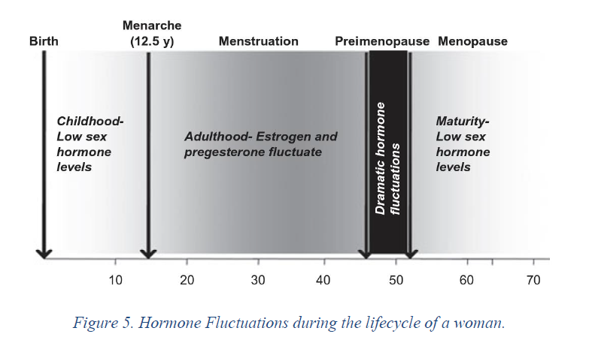

Fig 1. Female Menstrual intensity cycle

* 1. **Limitation of Existing System**

The Main limitation in here stands that ML/AI and Deep learning was only used for Migraine in general but not for Menstrual Migraine as such.

• **Use of K-means clustering in migraine detection by using EEG records under flash stimulation.**

o Based upon analyzing brain wave signals. Requires resources and is inefficient.

• **Analysis of repetitive flash stimulation frequencies and record periods to detect migraine using ANN.**

o Complex process of analyzing frequencies over time. Requires long duration and equipment to just detect migraine.

• **Comparison of artificial neural network and support vector machine classification methods in diagnosis of migraine by using EEG.**

o Similar to the previous ones.

• **The Migraine Aura.**

o Only intended to identify migraine with Aura (unrelated to non-aura migraines).

• **Migraine classification using magnetic resonance imaging resting**.

o Just provided insights upon pain circuits in the brain that acted as biomarkers to identify migraine patients.

• **Migraine classification by ML with functional near-infrared spectroscopy during the mental arithmetic task.**

o fNIRS & hemoglobin analysis is not quite the easy or standard way to quickly identify the types of migraine.

• **Automatic migraine classification via feature selection committee and ML techniques over imaging and questionnaire data.**

o DTI images & IQ questionnaires are a complex process to create classification models. Lot of scope for optimization.

• **Migraine Diagnosis Support System Based on Classifier Ensemble.**

o Does not provide any insights into types of migraines based on aura, and null on menstrual-related migraines.

• **Automatic migraine classification using artificial neural networks.**

o No significant EDA performed. Increased dimensions and incomprehensible correlations among the variables. Leaves scope for efficient system to build over neural networks (other than old MLP Classifier)

• **Diagnosis and Treatment of the Menstrual Migraine Patient.**

o Provides a perspective into post-identification procedures & treatments for women with menstrual migraine.

**2.4 Proposed System**

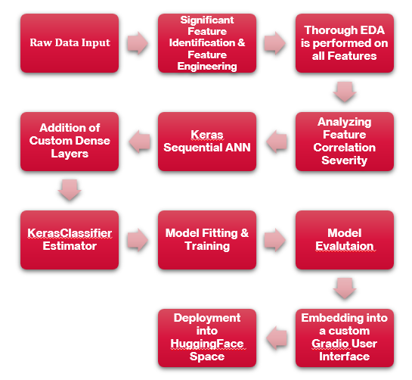

# **Chapter 3**

**METHODOLOGY**

**3.1 Dataset**

Data was collected from the *Code Ocean capsule*, in which the symptoms and the severity of each patient's symptoms were securely gathered and converted to a csv file for processing and quick access to the data.

**3.2 Architecture**

The customised Keras sequential ANN model, stacked with a KerasClassifier estimator, and used as input parameters for the proposed system result in an accurate prediction of the migraine classification model. The proposed system is implemented by primarily choosing the significant features that are highly correlated. The Gradio User Interface is used to implement the entire system.

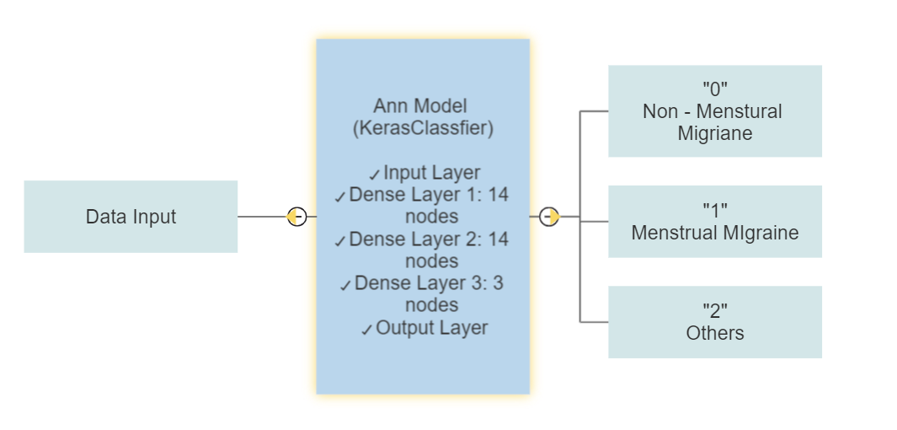

The input data will be sent into the kerasSequential model made with customized extra dense layers where each of layer has fourteen nodes and finally the output will be passed through the adam optimizer giving accurate result. Here the results are classified into three categories (0 – non menstrual migraine, 1 – menstrual migraine, 2 – others).

# **Chapter 4**

**TOOL DESCRIPTION**

* 1. **Hardware Requirements**
     + Processor: 8th Gen i5
     + Ram: 8GB
     + 64-bit Operating System
     + x64 – based processor
  2. **Software Requirements**
* NumPy, Pandas and Seaborn
* Matplotlib
* Sci-kit learn
* Python 3.10
* Gradio
* Hugging Face UI

# **Chapter 5**

**IMPLEMENTATION**

# **5.1 Data Collection**

Data was collected from the *Code Ocean capsule*, in which the symptoms and the severity of each patient's symptoms were securely gathered and converted to a csv file for processing and quick access to the data.

# **5.2 Feature Identification and Feature Engineering**

Primarily, 24 significant features have been identified and then the data has been cleaned by handling missing values using data imputation methods, and then the categorical data has been encoded based on the number of classes, wherein we used label encoding and replace methods.

# **5.3 Exploratory Data Analysis**

The correlation between features and the target variable has been analyzed using various Exploratory Data Analysis methodologies. The various charts/plots used in the EDA process are:

* Percentage Plots
* Histogram
* Violin Plot
* Box Plot
* Distribution plot with KDE and boxplots
* Count Plots

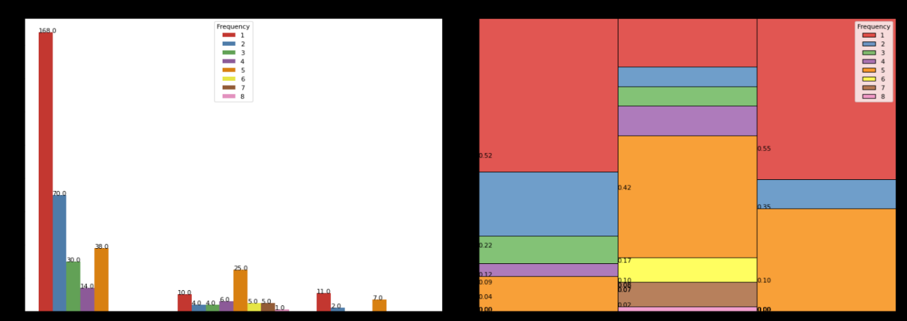

Fig 2 – percentage plot of frequency vs migraine type

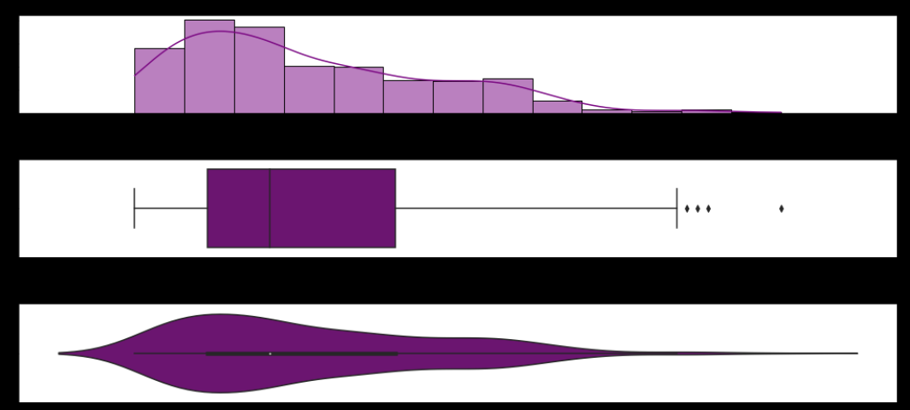

Fig 3 – histogram, boxplot and violin plot of intensity feature

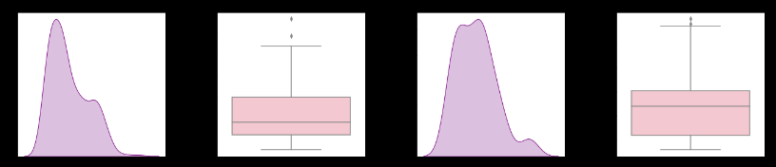

Fig 4 – Distribution plot with KDE and Boxplots for location feature

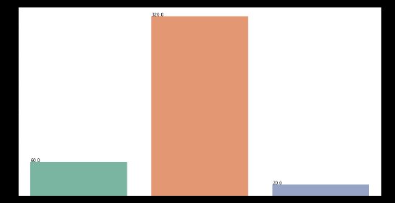

Fig 5 – count plot for migraine types

# **5.4 Keras Sequential ANN**

This is a baseline Keras Sequential model for multi-class classification. The model consists of two Dense layers with 14 units each, both using the Rectified Linear Unit (ReLU) activation function, in addition to the Baseline Model. The output layer has 3 units and uses the Softmax activation function, which is commonly used in multi-class classification tasks. The model is compiled with the categorical cross-entropy loss function, which is a measure of the dissimilarity between the predicted probabilities and the true probabilities, and the Adam optimizer, which is a popular stochastic gradient descent algorithm that uses adaptive learning rates and momentum to update the model parameters.

# **5.5 Keras Estimator**

An instance of the KerasClassifier class is a wrapper for the Keras Sequential model that allows it to be used with scikit-learn. The build_fn parameter is set to the baseline_model function that defines the architecture of the model. This function is called by the KerasClassifier to build the model. The classifier is set to 100 epochs with batch size of 10 per epoch and verbose set to ‘no logging’ i.e 0.

# **5.6 Model Training and Evaluation**

Finally, the data is fit into the model and it is trained and tested with the specified hyperparameters, thus providing accurate and improvised results as output predictions. The output class labels are into 3 categories: Menstrual Migraine, Non-Menstrual Migraine, and Others (irrelevant to menstrual migraine).

# **5.7 Gradio User Interface**

The Gradio interface is designed to predict the type of migraine based on 24 different input variables. These variables include age, duration, frequency, location, character, intensity, and various other symptoms related to migraine. The interface provides a text box for each of the 24 input variables, where the user can enter the corresponding value. The input values are then passed through a pre-trained KerasClassifier model that has been trained on a dataset of migraine data. Once the input values are passed through the model, the predicted output is returned as a text output component in the Gradio interface. The predicted output is one of three types of migraine: Non-Menstrual Migraine, Menstrual Migraine, or Others. To make the Gradio interface more user-friendly, the interface provides clear instructions on how to provide the necessary inputs. Additionally, the interface includes visual elements, such as images and textboxes, to provide additional information about the project and its authors.

The interface has three tabs, namely "Home", "Guidelines", and "Menstrual Migraine Model". The "Home" tab displays general information about the migraine predictor. The "Guidelines" tab provides instructions for providing input values to the interface. The "Menstrual Migraine Model" tab contains the interface for entering the input values and getting the predicted migraine type as output.

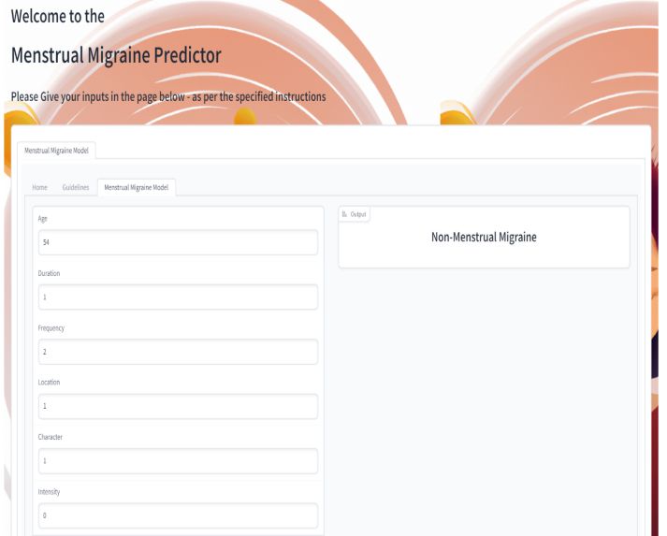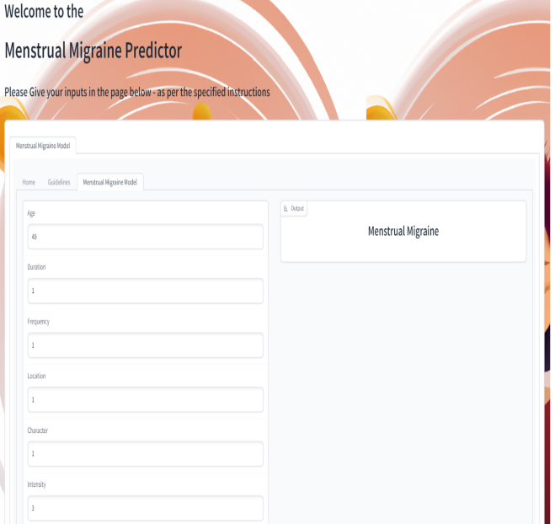

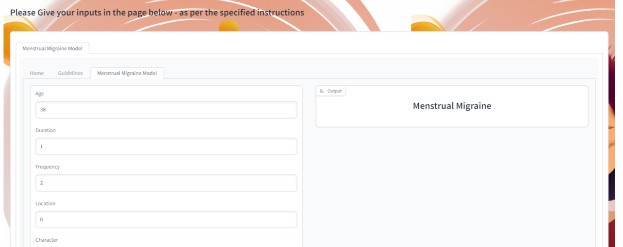

Fig 6 – model prediction output deployed on gradio UI predicting types of migraines for various user inputs.

# **Chapter 6**

**RESULTS AND CONCLUSION**

* 1. **Result Discussion**

Overall, the code defines a baseline Keras Sequential model with two hidden layers of 14 units each, ReLU activation functions, and a softmax output layer. Categorical cross-entropy loss function and the Adam optimizer are utilized to train the model. An accuracy of 88.72% was achieved by the model.

Based on the feature identification and feature engineering, it is anticipated that age plays a major role in menstrual migraine prediction and evaluating the symptom severity. The keras sequential model was optimized using custom dense layers along with keras estimator providing a recall value of 0.94, a precision of 0.89, and an accuracy of 88.72%.

**Chapter 7**

**FUTURE SCOPE**

**7.1 Future Scope**

The developed interface can be integrated with period tracker applications, providing complete information to the users regarding their migraine health condition during menstruation and suggesting appropriate actions based on the predictions. The interface can also be connected to a database, such that the system can store any new inputs and leverage them to continuously improve our model performance. The system can be scaled up through utilizing cloud architecture.

# **REFERENCES**

**[1]** Ahmet, Alkan, and Batuhan Akben Selahaddin. ***"Use of k-means clustering in migraine detection by using EEG records under flash stimulation."*** International Journal of Physical Sciences 6, no. 4 (2011): 641-650.

**[2]** Akben, Selahaddin Batuhan, Abdulhamit Subasi, and Deniz Tuncel. ***"Analysis of repetitive flash stimulation frequencies and record periods to detect migraine using artificial neural network."*** Journal of medical systems 36, no. 2 (2012): 925-931.

**[3]** Akben, Selahaddin Batuhan, Abdülhamit Subaşı, and Mahmut Kemal Kıymık. ***"Comparison of artificial neural network and support vector machine classification methods in diagnosis of migraine by using EEG."*** In 2010 IEEE 18th Signal Processing and Communications Applications Conference, pp. 637-640. IEEE, 2010.

**[4]** Charles, Andrew. ***"The migraine aura*."** Continuum: Lifelong Learning in Neurology 24, no. 4 (2018): 1009-1022.

**[5]** Chong, Catherine D., Nathan Gaw, Yinlin Fu, Jing Li, Teresa Wu, and Todd J. Schwedt. ***"Migraine classification using magnetic resonance imaging resting-state functional connectivity data."*** Cephalalgia 37, no. 9 (2017): 828-844.

**[6]** Ang, Kai Keng, Cuntai Guan, Kerry Lee, Jie Qi Lee, Shoko Nioka, and Britton Chance. ***"A brain-computer interface for mental arithmetic task from single-trial near-infrared spectroscopy brain signals."*** In 2010 20th International Conference on Pattern Recognition, pp. 3764-3767. IEEE, 2010.

**[7]** Garcia-Chimeno, Yolanda, Begonya Garcia-Zapirain, Marian Gomez-Beldarrain, Begonya Fernandez-Ruanova, and Juan Carlos Garcia-Monco*.* ***"Automatic migraine classification via feature selection committee and machine learning techniques over imaging and questionnaire data."*** BMC medical informatics and decision making 17, no. 1 (2017): 1-10.

**[8]** Jackowski, Konrad, Dariusz Jankowski, Dragan Simić, and Svetlana Simić. ***"Migraine diagnosis support system based on classifier ensemble."*** In International conference on ICT innovations, pp. 329-339. Springer, Cham, 2014.

**[9]** Sanchez-Sanchez, Paola A., José Rafael García-González, and Juan Manuel Rúa Ascar. ***"Automatic migraine classification using artificial neural networks."*** F1000Research 9 (2020).

**[10]** Silberstein, Stephen D., and Susan L. Hutchinson. ***"Diagnosis and treatment of the menstrual migraine patient."*** Headache: The Journal of Head and Face Pain 48 (2008): S115-S122.

# **APPENDIX**

1. [*https://www.healthline.com/health/migraine/migraine-during-period*](https://www.healthline.com/health/migraine/migraine-during-period)
2. [*https://my.clevelandclinic.org/health/diseases/8260-menstrual-migraines-hormone-headaches*](https://my.clevelandclinic.org/health/diseases/8260-menstrual-migraines-hormone-headaches)
3. [*https://pubmed.ncbi.nlm.nih.gov/35015948/*](https://pubmed.ncbi.nlm.nih.gov/35015948/)
4. [*https://en.wikipedia.org/wiki/Artificial_neural_network*](https://en.wikipedia.org/wiki/Artificial_neural_network)
5. [*https://en.wikipedia.org/wiki/Menstrual_migraine*](https://en.wikipedia.org/wiki/Menstrual_migraine)
6. [*https://www.forbes.com/health/family/menstrual-migraines/*](https://www.forbes.com/health/family/menstrual-migraines/)
7. [*https://americanheadachesociety.org/wp-content/uploads/2018/05/Vincent_Martin_-_Menstrual_Martin-1.pdf*](https://americanheadachesociety.org/wp-content/uploads/2018/05/Vincent_Martin_-_Menstrual_Martin-1.pdf)
8. [*https://a.org/neural-networks*](https://a.org/neural-networks)
9. [*https://journals.plos.org/plosone/article?id=10.1371%2Fjournal.pone.0212356*](https://journals.plos.org/plosone/article?id=10.1371%2Fjournal.pone.0212356)
10. [*https://pubmed.ncbi.nlm.nih.gov/30779785/*](https://pubmed.ncbi.nlm.nih.gov/30779785/)